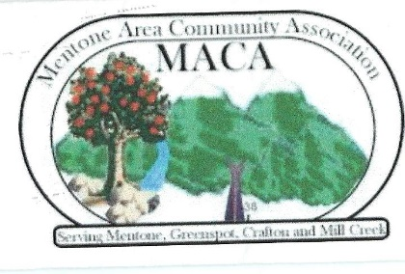
7th Annual Mentone Crockpot Chili Cook Off
SATURDAY, JUNE 11 2022
SPONSORED BY MENTONE CHAMBER OF COMMERCE

THERE IS NO ENTRY FEE! CALL (909) 362 7860
Competition is limited (closed) to the first 12 contestants signed up!
The contest will be held at the Sandals Church Grounds as a side event for the 2022 Mentone Birthday Event! All participants must follow these rules. Plaque, Trophy, and /or gift card will be awarded.
Sandals Church 1325 Amethyst Ave Mentone CA 92359--east end of Mentone
RULES
- Participants shall prepare a six (6 quart) ready to serve, heated, homemade, crockpot chili. Made that day.
- Submit your chili by 11:45 a.m. The contest ends 2 p.m.
- Participant is responsible for suppling their own small serving ladle. Participant will be sure crockpot is HOT upon arrival.
- Each participant will be assigned an official judging cup. Each participant should verify that the top and bottom number of their cup is the same as their assigned participant number. Volunteers will deliver the participant’s numbered chili cup to the judges for their tasting.
- Judges vote in a private area. Judge criteria as follows: Good Flavor, Thick Consistency, Blend of Spices, Aroma, and Deep Color. “People’s Choice” is awarded to the chili that the public test tastes frequently and submits voting ticket. Most votes reveal winner! Decision of CHIEF JUDGE shall be final authority for 1st place and honorable mention awards.

